

Data Analytics Data Director System

(DA - DDS) User Guide

Table of Contents

General Overview 3

Features and Functionality 4

User Friendly 4

User Verification 4

Parallel Job Scheduling and Execution 4

Efficient 4

Options to reduce Data Corruption 4

Integrated with RiskMaster 4

DA DDS – UI (User Interface) 5

DDS OPTIONSET PAGE 6

CONFIG NAME 7

OPTIONSET NAME 8

IMPORT AREAS 8

GLOBAL OPTIONS 8

CHOOSE FILE 12

EVENT IMPORT AREA 13

CLAIM IMPORT AREA 16

PAYMENT IMPORT AREA: 20

MEDWATCH IMPORT AREA: 22

ADJUSTER NOTES IMPORT AREA: 24

ENHANCED NOTES IMPORT AREA: 25

SHORT TERM DISABILITY IMPORT AREA: 27

RESERVE MAPPING TAB 29

SUPPLEMENTAL FIELDS 31

Files Generated 34

DA DDS – UV (User Verification) 35

Introduction 35

User Verification Screen 35

DA DDS – Implementation Approach 40

Introduction 40

Points to Remember 41

Functionalities Improved In DA 42

COMMON 42

EVENT IMPORT AREA 43

CLAIM IMPORT AREA 43

PAYMENT IMPORT AREA 44

SHORT TERM DISABILITY IMPORT AREA 44

# General Overview

RISKMASTER Data Analytics completely automates Self-Insurance import/export extract processing. It brings together several standalone extract modules in RISKMASTER and combines them together under one umbrella. You can use the RISKMASTER Task Manager to schedule any of the extracts included in the Data Analytics system.

DA DDS has new improved performance and standard. Unlike Desktop, it doesn’t needs to be installed on every machine. Multiple users can use it by just having DA 4.2 on their machines.

DA DDS replaces legacy VB import/export extracts with Rich BI enabled Data Integrator extracts.

DA DDS is built to work on RiskMaster 16.1 and will also cater future versions. However, it is not advisable to use DA DDS below RiskMaster 16.1.

The Data Analytics Data Director User Guide describes the functionality of DDS and how to use it. It also gives the user interface and what possible errors a user can face while saving the Option set page.

# Features and Functionality

User Friendly

* An Interface arranged into blocks and tabs based on the different types of options and settings.
* DA DDS provides a single View, which is easy to understand, visualize and configure.
* Error and warning messages points to exact location of errors.
* Configurations to save selection which reduces efforts to schedule a job.

## User Verification

* A way to view and modify the records which failed validations.
* Verify and Change fields with validation Errors.
* Ease to resume the Job for Failed Validations after modifications.
* Save efforts in altering the records in the Import file and Rescheduling the job.

Parallel Job Scheduling and Execution

* It offers Multiple Job Scheduling by Multiple users in a Single Environment.
* Parallel Job execution, Data Loading, Validations and Insertion.

Efficient

* Improved performance with Bulk data.

## Options to reduce Data Corruption

* Check for duplicate Entities  
  Checks multiple entries for entities before linking one of them to any Area.
* Allow creation of new entities  
  No Automatic Entity creation whenever the Entity does not exists in RiskMaster.

Integrated with RiskMaster

* Save settings/Configuration for a particular job to use it in Future.
* Reduces efforts in selecting all the settings every time a job is scheduled.
* Multiple configurations based on various import areas, reserve selections, Supplemental field mappings etc.
* Configurations maintenance for every RiskMaster user using DA DDS.

# DA DDS – UI (User Interface)

1. Login to RiskMaster.
2. Go to Utilities -> tools & designer -> Task Manager -> View Scheduled Tasks

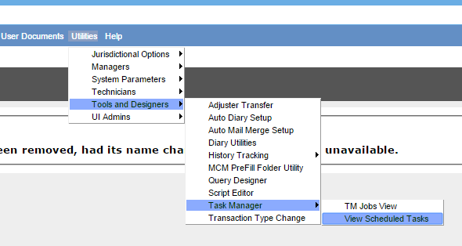

**Figure 1.** View Scheduled Tasks

1. Once you click ‘Schedule Task’. Select the Task Type as ‘DDS’

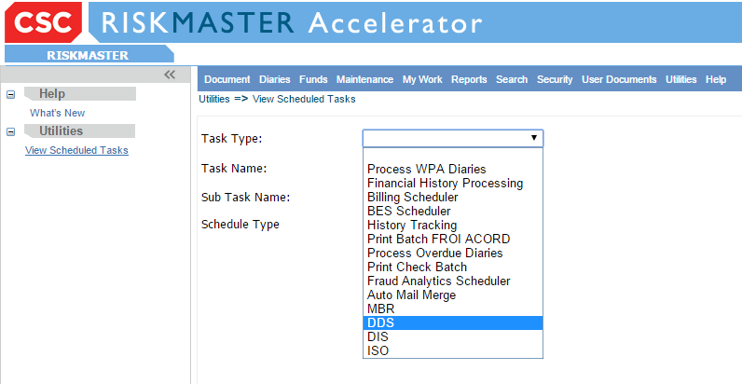

**Figure 2.** Schedule DA DDS Job

1. Select Date & Enter Time as required. Click on Optionset.

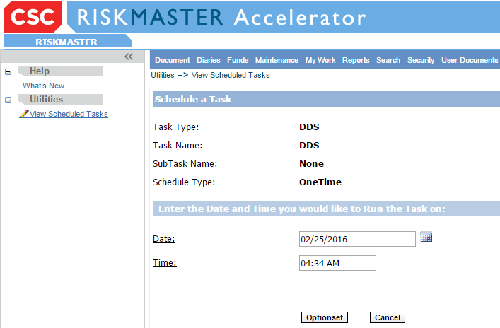

**Figure 3.** Schedule the timings

DDS OPTIONSET PAGE

All the mandatory fields are in **bold** letters. You must fill the information in these mandatory fields to avoid errors.

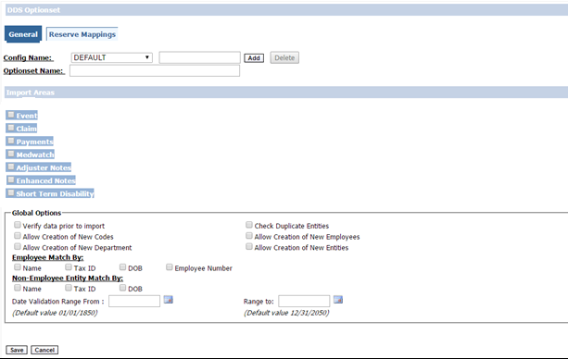

**Figure 4.** DDS Optionset Screen

CONFIG NAME

It is used to save all the settings done by the user on the DDS Optionset page while scheduling a job. As there are many settings/options on the DDS Optionset page, the *‘****Config Name’*** saves the overhead for the user to select all the settings every time a job needs to be scheduled.  
 **Default Config Name:** When the User is scheduling a job for the first time, all the setting/options selected by the User gets automatically added under ***‘DEFAULT’*** config name when the Job is saved**.**

**Add Config Name**:   
When the User tries to schedule a job for the second time or for any other occurrence, DDS loads the last configuration used by the User and all the settings/options will be reflected on DDS Optionset page. If User wants to change the setting/options selected then a new Config Name has to be entered followed by click on add button. Alternatively, user can select Config name from a list of config added by the user.  
 **Delete Config Name:** The user can **soft** delete the configuration present in the Config Name drop down list. Once any config name has been deleted it would not be available in the drop down list.

OPTIONSET NAME

A Unique name is required each time a job is scheduled

IMPORT AREAS

Currently DA DDS supports three import Areas mentioned below:

* Events
* Claims
* Payments
* Medwatch
* Adjuster Notes
* Enhanced Notes
* Short Term Disability

User can select a combination of these three to run their Jobs.

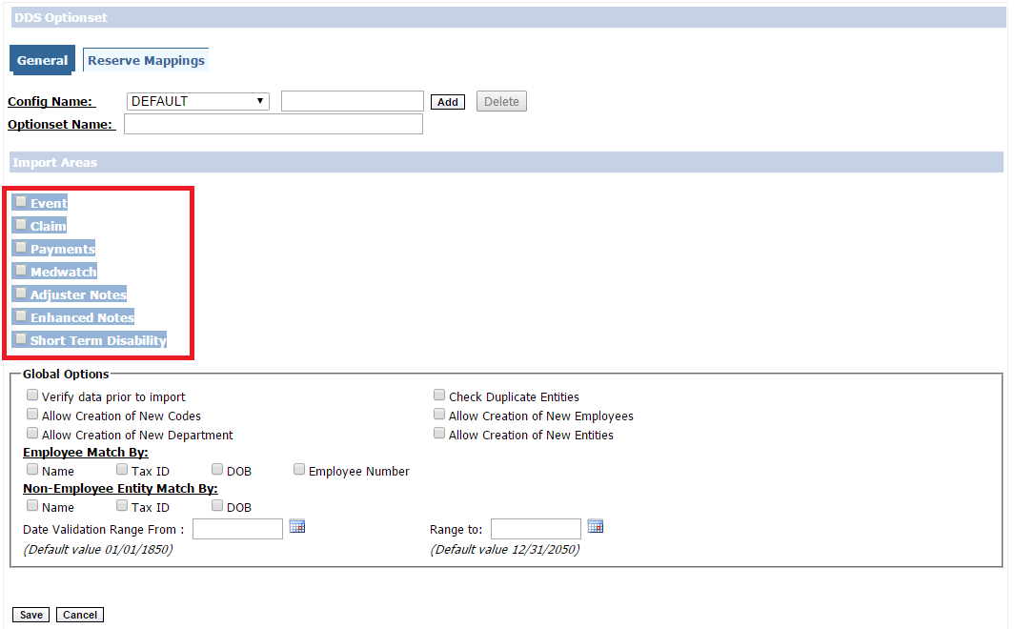

**Figure 5.** DDS Optionset Import Areas

GLOBAL OPTIONS  
  
Global Options are a common set of options that can be used in all import areas.  
  


**Figure 6.** DDS Global Options

Click on the check boxes if you require the validations mentioned below:

* **Verify data prior to import**

This is User verification checkbox. Please refer the user verification on Page 27.

* **Allow Creation of New Codes**

If user selects this checkbox and provides a Short Code in the import file that does not exist in the RiskMaster, then a new Short Code would be created for the mentioned new short code in the CODES table of RiskMaster.  
 **Note:***DA DDS creates only User Codes, but still not all the User Short Codes are created by DA DDS. Short Codes which require a parent or Industry standard codes are not created through DA DDS. User would have to create these short codes using RiskMaster.*

* **Allow Creation of New Department**  
  If user selects this checkbox and has given a Department in the import file that does not exist in the RiskMaster, then a new Department would be created for the mentioned new department in the ENTITY Table and also an Organization Hierarchy would be created in ORG_HIERARCHY Table.

* **Check Duplicate Entities**

If user selects this checkbox and already given an entity in the import file that exists in the RiskMaster, an error would be logged. No new entity would be created in such scenario which would prevent duplicates from being created in RiskMaster.

* **Allow Creation of New Employees**

If user selects this checkbox and has given an Employee in the import file that does not exist in the RiskMaster, then a new entry would be created for the mentioned new Employee in the Employee and Entity Table.

* **Allow Creation of New Entities**

If the user selects this checkbox and a new Entity is provided in the import file that does not exist in the RiskMaster, then a new entry would be created for the mentioned new Entity in the Entity table.

* **Employee Match By**

This a mandatory field on DDS Optionset page. Select at least one of the three matches to avoid a validation error. A combination of all three could also be selected.

***Note:*** *Employee Match By is used for searching Entities provided in import file of* ***Employee Type*** *in RiskMaster.*

1. **Match by Tax ID**  
   When you select the checkbox **‘TAX_ID’** you need to provide the TAX_ID in the import file and it will check the same in the RiskMaster and if the Tax ID does not exists in the RiskMaster corresponding to that Tax ID, an error will be logged.
2. **Match by Name**When you select checkbox **‘Name’** then you need to provide the Name in the import file and it will check the same in the RiskMaster and if the Name does not exists in the RiskMaster corresponding to that Employee number, an error will be logged.
3. **Match by DOB**

When you select checkbox **‘DOB’** then you need to provide the Date of Birth in the import file and it will check the same in the RiskMaster and if the Date of Birth does not exists in the RiskMaster corresponding to that Employee number, an error will be logged.

1. **Match by Employee Number**When you select the checkbox **‘Employee Number’,** you need to provide the Employee Number in the import file and it will check the same in the RiskMaster and if the Employee Number does not exists in the RiskMaster corresponding to that Employee number, error will be logged.

***Note:*** *Import file must always have the Name whether you’ve selected the ‘Name’ checkbox or not as Name is a Mandatory field for creating an Entity.*

* **Non-Employee Entity Match By**

This a mandatory field on DDS Optionset page. Select at least one of the three matches to avoid a validation error. A combination of all three could also be selected.  
 ***Note:*** *Employee Match By is used for searching Entities provided in import file of* ***Non****-****Employee Type*** *or* ***Other Type*** *in RiskMaster.*

* 1. **Match by Tax ID**  
     when you select the checkbox **‘TAX_ID’** then TAX_ID is mandatory in the import file. It will check the same in the RiskMaster. If the Tax ID does not exist in the RiskMaster corresponding to that Tax ID, an error will be logged.
  2. **Match by Name**When you select checkbox **‘Name’,** you need to provide the Name in the import file and it will check the same in the RiskMaster and if the Name does not exists in the RiskMaster corresponding to that Employee number, an error will be logged.

***Note:*** *Import file must always have the Name whether you’ve selected the ‘Name’ checkbox or not as Name is a Mandatory field for creating an Entity.*

* 1. **Match by DOB**  
     When you select checkbox **‘DOB’,** you need to provide the Date of Birth in the import file and it will check the same in the RiskMaster and if the Date of Birth does not exists in the RiskMaster corresponding to that Employee number, an error will be logged.

**Date Range**

* **Date Validation Range from**Lower value of the Date range needs to be provided.

The default date 01/01/1850 will be considered as the lower value if the User does not selects any date.

* **Date Validation Range to**Upper value of the Date range needs to be provided.

The default date 12/31/2050 will be considered as the Upper value if the User does not selects any date.

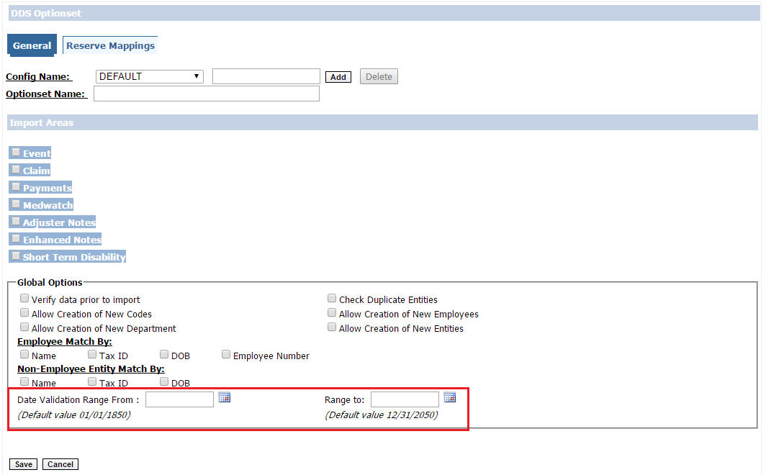

**Figure 7**. DDS Optionset, Date Validation Range

***Note:*** *‘From date’ must be a date prior to ‘To Date’ otherwise a validation error would be displayed on DDS Optionset page.*

CHOOSE FILE

Browse a CSV file for the selected import area

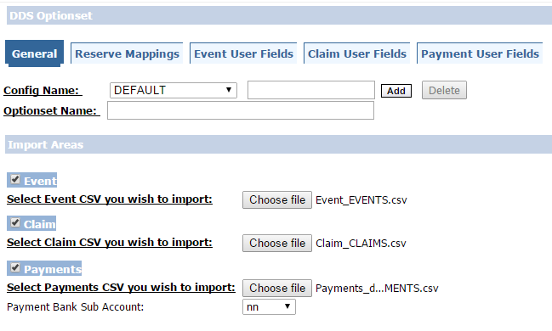

**Figure 8**. DDS Optionset, Choose Import file

***Note:*** *The CSV file need not be with the exact name as the selected import areas. For example, for Event import area you may select a CSV file named as EVENT12345.csv or any other name that the user prefers.*

EVENT IMPORT AREA

Once you Select Event checkbox, **‘Event User fields’** tab, **‘Event Options’** will be visible.

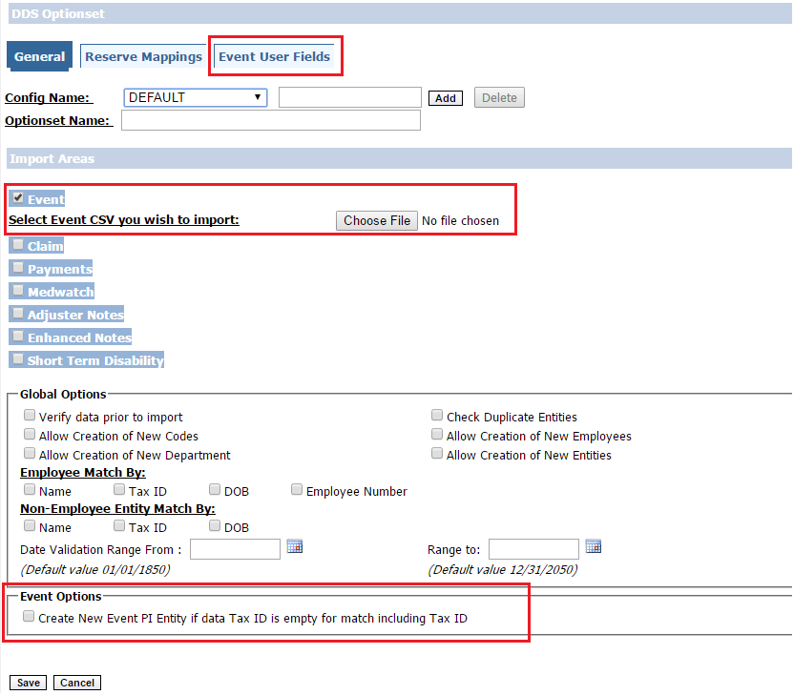

**Figure 9.** DDS Optionset, Event Import Options

**Event Options**

***‘Create New Event PI Entity if data Tax ID is empty for match including Tax ID’***

The Event record will error out when the user has selected **‘Match by Criteria’** as **‘TAX ID’** and TAX_ID data is not available in the Events Import file.

If the User selects this checkbox, then the Event Record will not error out, even if the TAX_ID data is not present in the Event import file. A new Entity would be created in RiskMaster a NULL value in TAX_ID field.

**EVENT USER FIELDS**

EVENT USER FIELDS tab would be Visible if ‘Event’ checkbox is selected. User will be able to map all the Fields in the Supplemental tables with the Fields in the Import area.

Select **Mapped** Checkbox to map Supplemental table and supplemental fields with Fields in Event Import file.

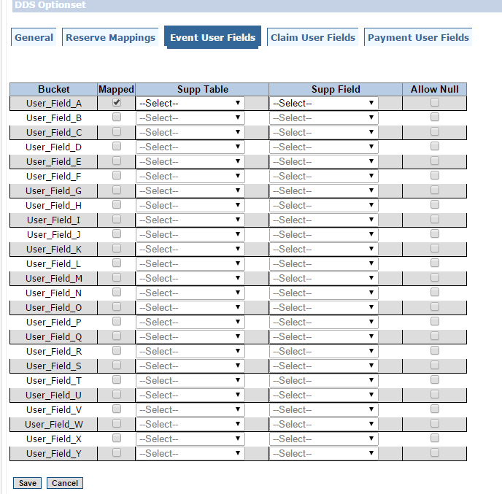

**Figure 10.** DDS Optionset, Event User Fields

Supplemental fields created through RiskMaster for a particular Supplemental Table only will appear in **‘Supp Field’** drop down menu.

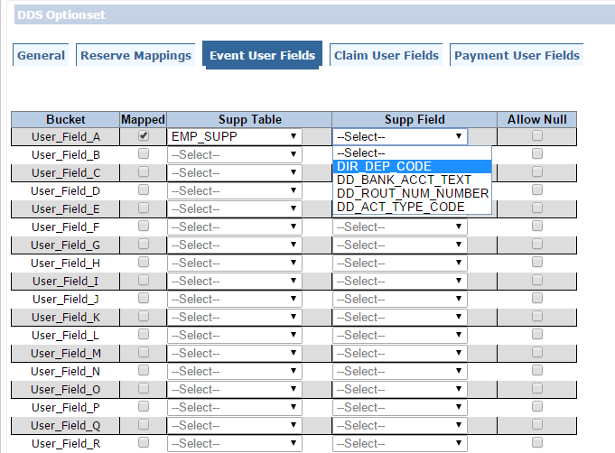

**Figure 11.** DDS Optionset, Event User Fields

If the User has selected the Mapped checkbox and no mapping has been done, an error message would be displayed when User tries to save the Optionset.

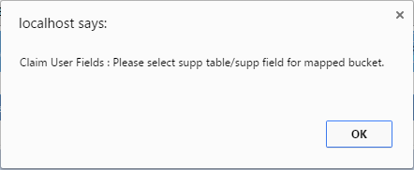

**Figure 12.** Error, Claim User Fields

## CLAIM IMPORT AREA

Once you Select Claim checkbox, **‘Claim User fields’** tab, **‘Claim Options’** would be visible.

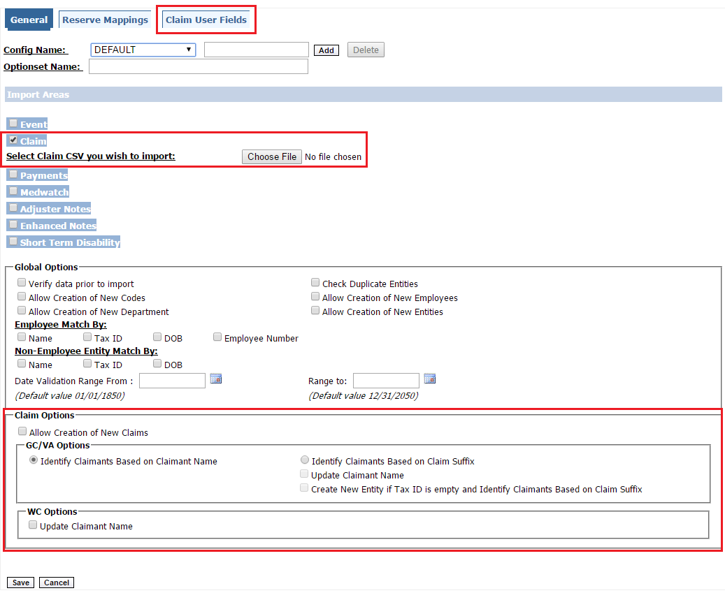

**Figure 13.** DDS Optionset, Claim Import Area

**Claim Options**

* **Allow Creation of New Claims**

Selection of this checkbox would allow creation of new claims if the claims that user has provided in the import file does not exists in RiskMaster, Otherwise an error would be logged and Claim would not be created.

* **GC/VA Options** – Options for General & Vehicle claims

‘**Identify Claimant Based on Claimant Name’**  
If checked then claimant would be searched in RiskMaster on the basis of Claimant Name provided in Import file.

‘**Identify Claimant Based on Claim Suffix**’

If checked then claimant would be searched in RiskMaster on the basis of Claim Suffix provided in Import file

* **WC Options**- Option’s for Worker’s compensation claims  
    
  **‘Update Claimant Name’**

If checked, Claimant last name and first name in RiskMaster would be updated by Claimant last name and first name provided in the import file corresponding to the particular claimant**.  
Note:** *DDS does not support property claims.*

**CLAIM USER FIELDS**

CLAIM USER FIELDS tab would be Visible if ‘Claim’ checkbox is selected. User will be able to map all the Fields of the Supplemental tables with the Fields in the Import area.

Select **Mapped** Checkbox to map Supplemental table and supplemental fields with Fields in Claim Import file.

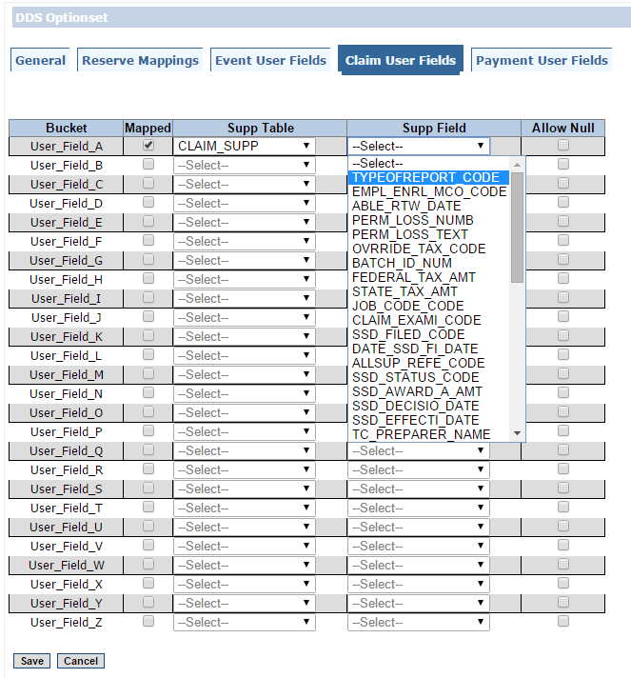

**Figure 14.** DDS Optionset, Claim User Fields

Supplemental fields created through RiskMaster for a particular Supplemental Table will appear in **‘Supp Field’** drop down menu.

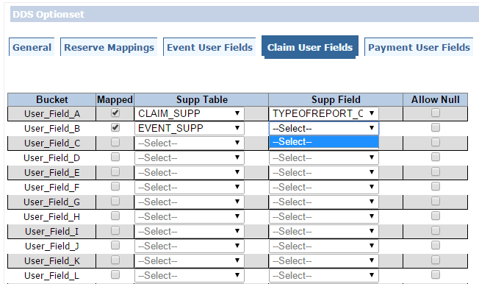  
  
  
Also, if you have selected the Mapped checkbox and the no mapping is done. You will again get an error message when you try to save the Option set.

**Figure 15.** DDS Optionset, Claim User Fields



**Figure 16.** Error, Claim User Field

PAYMENT IMPORT AREA:

Once you select Payment checkbox, **‘Payment User fields’** tab and **‘Payment Options’** would be visible.

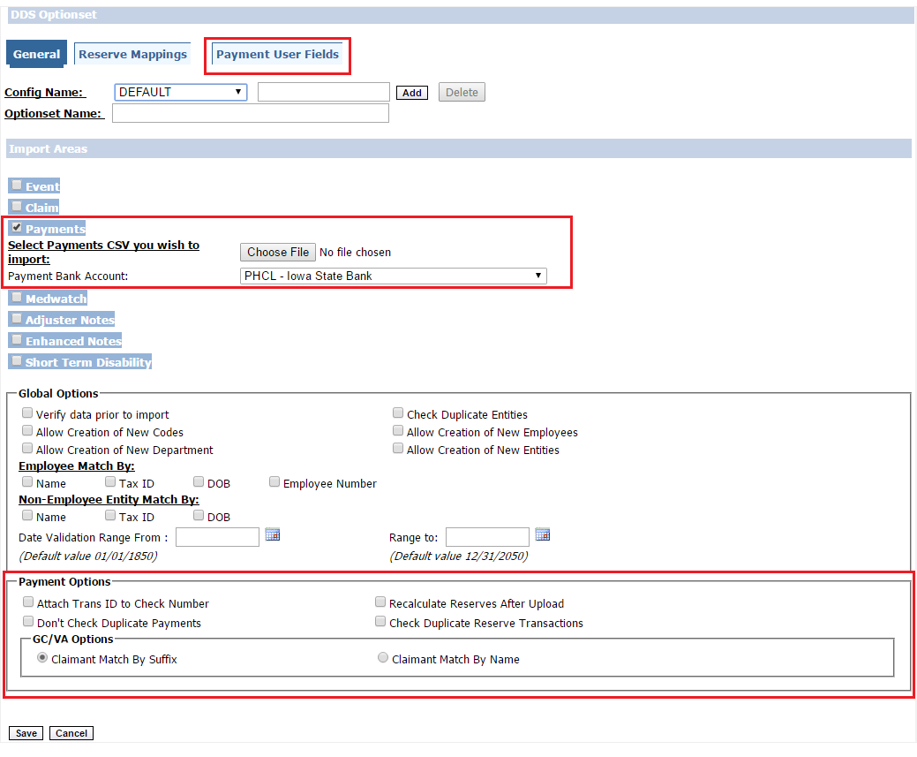

**Figure 17.** DDS Optionset, Payments Import Area

**Payment Options**

* **Attach TRANS ID to Check Number**

TRANS_ID is a unique ID for each Transaction in RiskMaster and is automatically generated when any Transaction is created.  
Check number has to be a unique number for each Transaction and is provided in the Import file.  
If the user does not have a unique check number in import file then this checkbox is selected then DA DDS would append the TRANS_ID with Check number so that Check Number becomes unique for each Transaction.

* **Don’t Check Duplicate Payments**

This checkbox would allow duplicate Payments in RiskMaster even if the User is making the duplicate payment corresponding to the same employee.

* **Recalculate Reserves after Upload**This checkbox assures rebalancing of the reserve every time after any payment/collection has been made.
* **Check Duplicate Reserve Transactions**This checkbox would check for duplicate reserve transactions in RiskMaster.

**PAYMENT USER FELDS:**

PAYMENT USER FIELDS tab would be Visible if ‘Claim’ checkbox is selected. User will be able to map all the Fields of the Supplemental tables with the Fields in the Import area.

Select **Mapped** Checkbox to map Supplemental table and supplemental fields with Fields in Claim Import file.

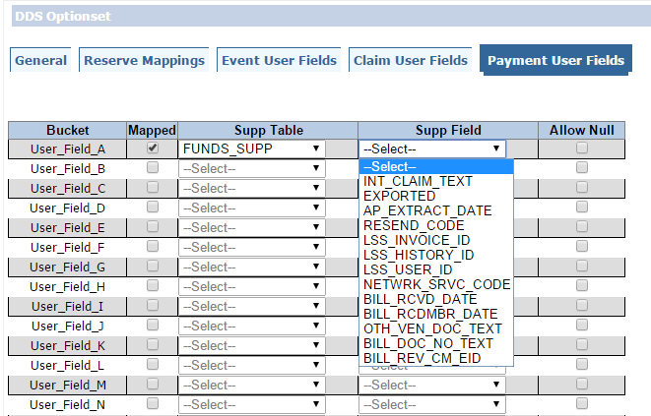

**Figure 18.** DDS Optionset, Payment User Field

Supplemental fields created through RiskMaster for a particular Supplemental Table will appear in **‘Supp Field’** drop down menu.

Also, if you have selected the Mapped checkbox and no mapping is done. You will again get an error message when you try to save the Option set.



**Figure 19.** Error, Payment User Fields

MEDWATCH IMPORT AREA:

Once you select Medwatch checkbox, **‘MEDWATCH User fields’** tab would be visible.

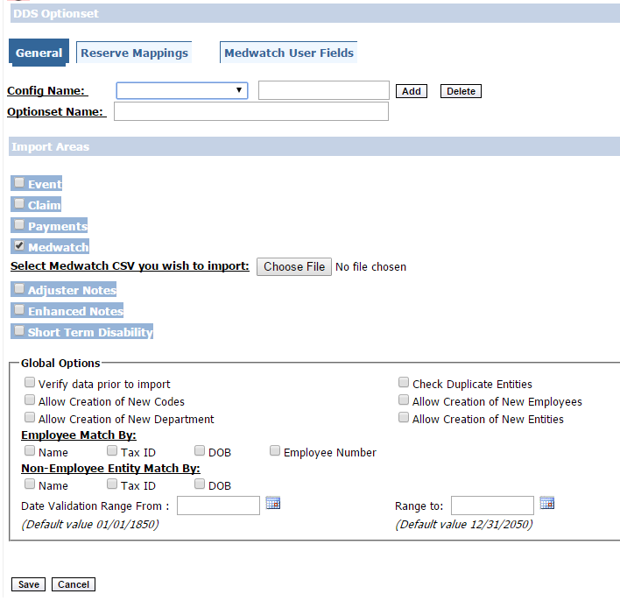

**Figure 20.** DDS Optionset, Medwatch Import Area

**MEDWATCH USER FIELDS:**

MEDWATCH USER FIELDS tab would be Visible if **‘Medwatch’** checkbox is selected. User will be able to map all the Fields of the Supplemental tables with the Fields in the Import area.

Select **Mapped** Checkbox to map Supplemental table and supplemental fields with Fields in Claim Import file.

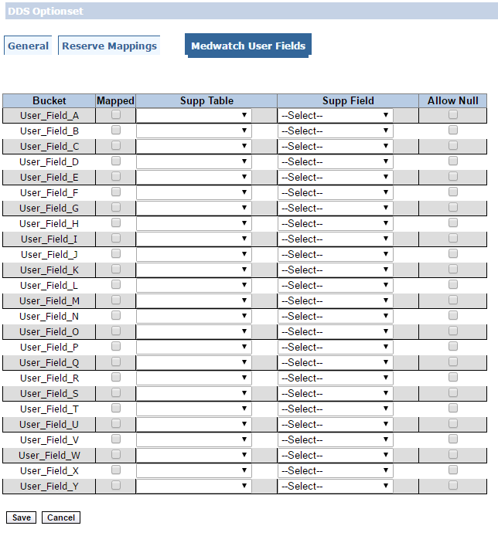

**Figure 21.** DDS Optionset, Medwatch User Field

Supplemental fields created through RiskMaster for a particular Supplemental Table will appear in **‘Supp Field’** drop down menu.

Also, if you have selected the Mapped checkbox and no mapping is done. You will again get an error message when you try to save the Option set.



**Figure 22.** Error, Medwatch User Fields

ADJUSTER NOTES IMPORT AREA:

Once you select Adjuster Notes checkbox **‘Adjuster Notes Options’** would be visible.

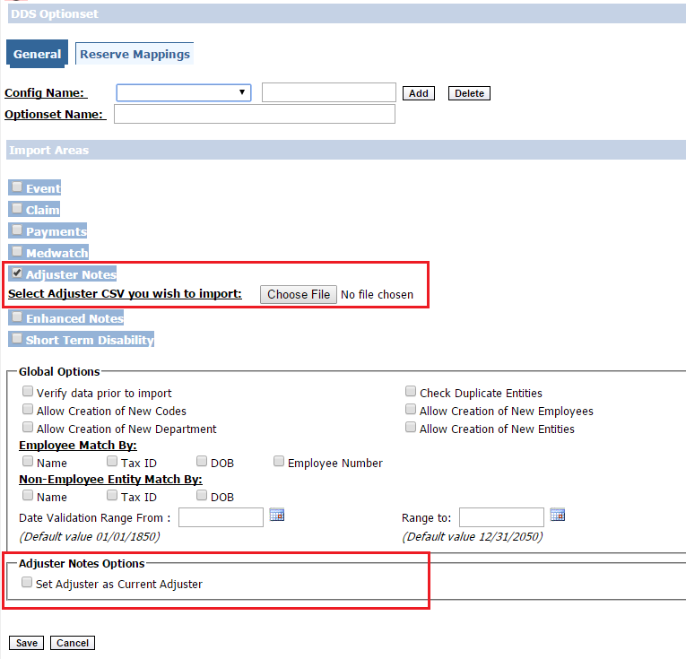

**Figure 23.** DDS Optionset, Adjuster Notes Import Area

**Adjuster Notes Options**

* **Set Adjuster as Current Adjuster**  
  This Checkbox would allow us to set Adjuster for a particular Claim specified in the Import file as the current adjuster.

ENHANCED NOTES IMPORT AREA:

Once you select Adjuster Notes checkbox **‘Enhanced Notes Options’** would be visible.

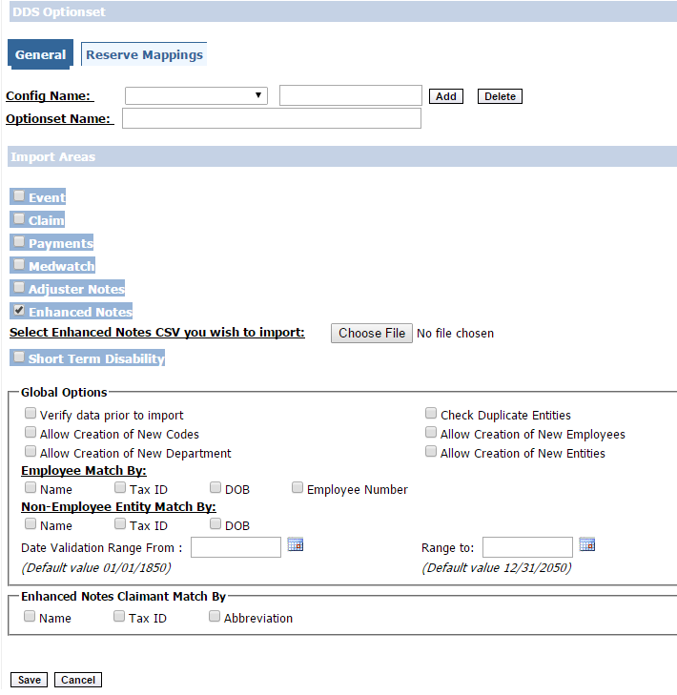

**Figure 24.** DDS Optionset, Enhanced Notes Import Area

**Enhanced Notes Options**

**Enhanced Notes Claimant Match by**  
This a mandatory field for Enhanced Notes. Select at least one of the three matches to avoid a validation error. A combination of all three could also be selected.  
 ***Note:*** *Enhanced Notes Match By is used for searching Entities provided in import file of* ***Claimant*** *or* ***Other Type*** *in RiskMaster.*

1. **Match by Name**When you select checkbox **‘Name’,** you need to provide the Name in the import file and it will check the same in the RiskMaster and if the Name does not exists in the RiskMaster corresponding to that Claimant, an error will be logged.

***Note:*** *Import file must always have the Name whether you’ve selected the ‘Name’ checkbox or not as Name is a Mandatory field for creating an Entity.*

1. **Match by Tax ID**  
   when you select the checkbox **‘TAX_ID’** then TAX_ID is mandatory in the import file. It will check the same in the RiskMaster. If the Tax ID does not exist in the RiskMaster corresponding to that Tax ID, an error will be logged.
2. **Match by Abbreviation**  
   When you select checkbox **‘Abbreviation’,** you need to provide the Abbreviation in the import file and it will check the same in the RiskMaster and if the Abbreviation does not exists in the RiskMaster corresponding to that Claimant, an error will be logged.

SHORT TERM DISABILITY IMPORT AREA:

Once you select Short Term Disability checkbox, **‘Short Term Disability Plan User fields’** tab would be visible.  
  
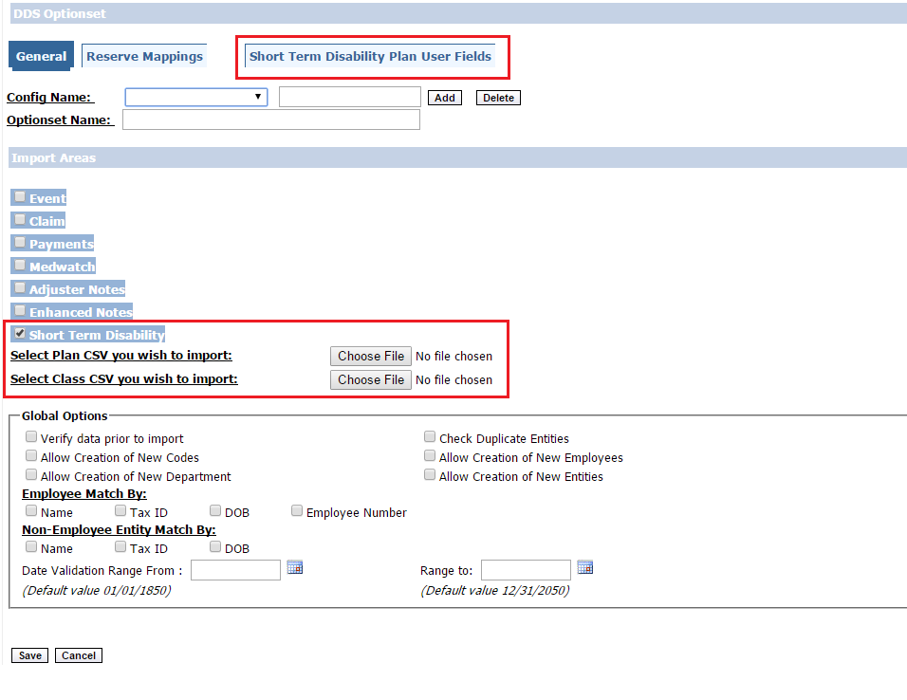

**Figure 25.** DDS Optionset, Short Term Disability Import Area

Short Term Disability Import area supports two import files.

* Short Term Disability Plan
* Short Term Disability Class

At least one import file should be selected to avoid a validation error.

**SHORT TERM DISABILITY PLAN USER FIELDS**

Short Term Disability Plan User Fields tab would be Visible if **‘Short Term Disability Plan’** checkbox is selected. User will be able to map all the Fields of the Supplemental tables with the Fields in the Import area.

Select **Mapped** Checkbox to map Supplemental table and supplemental fields with Fields in Claim Import file.

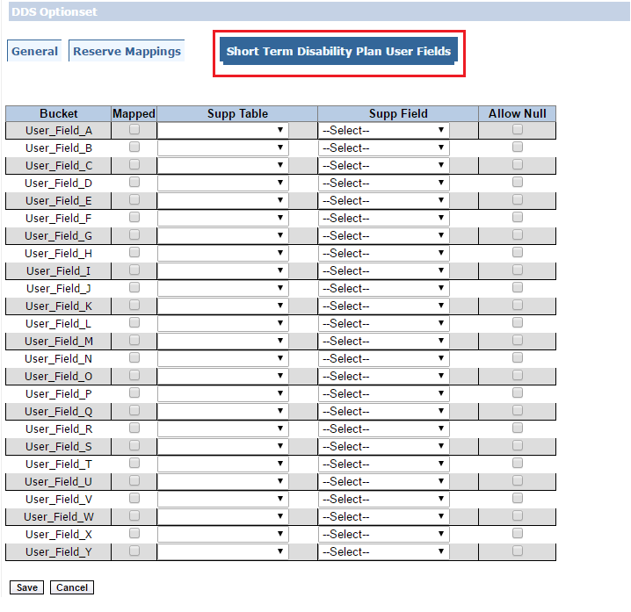

**Figure 26.** DDS Optionset, Short Term Disability Plan User Field

Supplemental fields created through RiskMaster for a particular Supplemental Table will appear in **‘Supp Field’** drop down menu.

Also, if you have selected the Mapped checkbox and no mapping is done. You will again get an error message when you try to save the Option set.



**Figure 27.** Error, Short Term Disability Plan

## RESERVE MAPPING TAB

Reserve Mapping Tab provides the User an Option to Map Reserve Types created in RiskMaster with Buckets and Fields in Import file for DA DDS. Only Claims and Payments Import areas Support this tab.  
  
DA DDS supports four Line of Businesses which are mentioned below:

* GC General Claims
* WC Worker’s Compensation
* DI Disability Claims
* VA Vehicle Claims

**Note:** Property Claims are not supported by DA DDS  
  
**Reserve Mapping for Claims import area**

One record in Claims import area is specific to a single Line of business. There are five set of fields for each bucket in a record.  
I.e. for Bucket A below mentioned fields are present  
  
RESERVE_A_OPENING,  
RESERVE_A_CURRENT,  
RESERVE_A_DATE,  
PAID_A_TOTAL,  
COLLECTION_A_TOTAL

In a similar way bucket B, C, D, E are also there.

**Reserve Mapping for Payments import area**

One record in Payment import area is specific to a single Line of business. There is a Type flag in each record in which we specify any of the buckets mapped.  
A, B, C, D, E is the valid values.

**Follow the below mentioned steps to map a reserve**

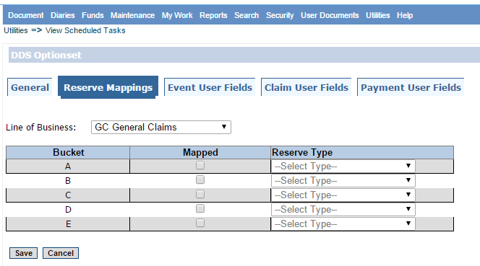

**Figure 28.** DDS Optionset, Reserve Mappings

1. Select the Line of Business

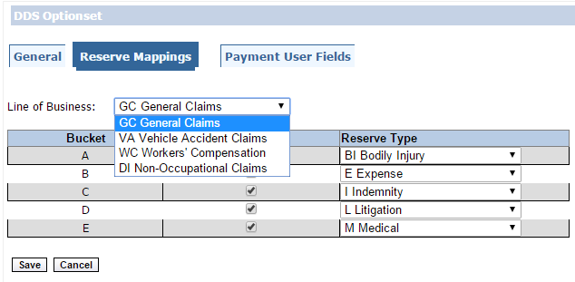

**Figure 209.** DDS Optionset, Line Of Business

b) Select the Reserve type after checking the Mapped checkbox.

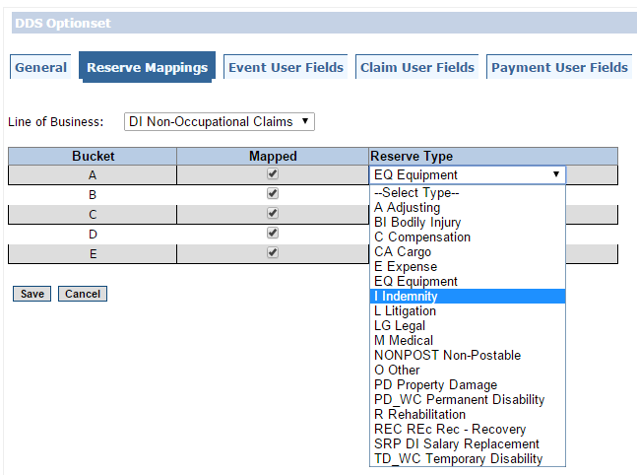

**Figure 30.** DDS Optionset, Reserve Type

c) If one of the 5 Mapped checkbox is selected and no Reserve Type is mapped corresponding to it, an error message will pop out.

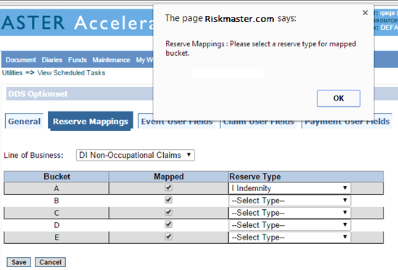

**Figure 211.** Error, Reserve Mappings

SUPPLEMENTAL FIELDS  
  
Supplemental fields are created by the user corresponding to the supplemental tables through RiskMaster. Supplemental fields are used to store some additional/supplemental information corresponding to the business requirements specific to client.

To create a new supplemental field-

Go to Utilities -> UI Admins -> Supplemental Setup -> Supplemental Field data

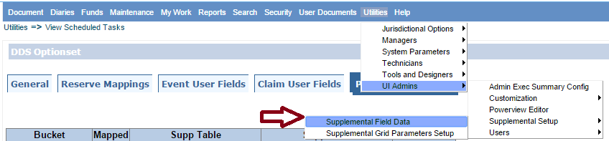

**Figure 32.** Supplemental Field data

1. If you have to add supplemental fields to Event Supp tables. Go to edit

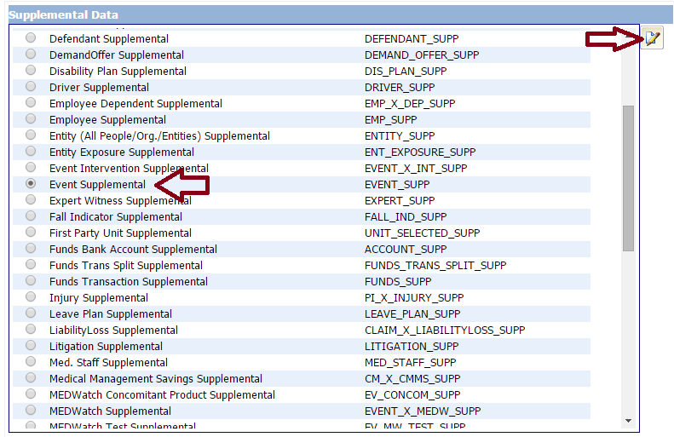

**Figure 33.** Supplemental Data

1. Go to New

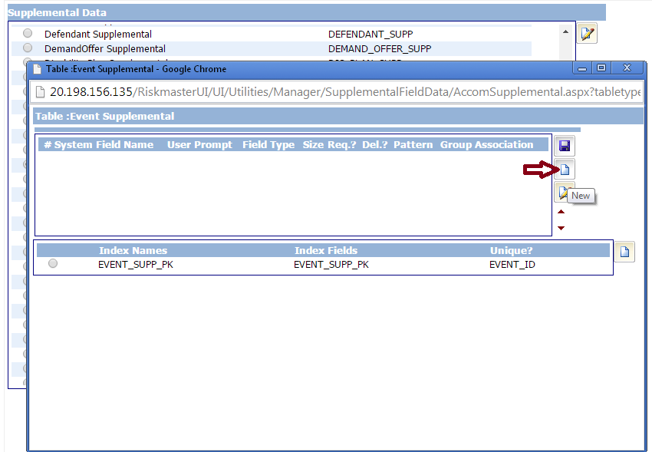

**Figure 34.** Table Event Supplemental

1. Enter the required information and save the field.

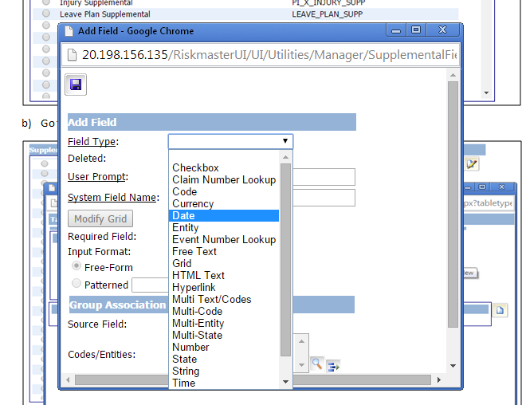

**Figure 35.** Add Supplemental Field

1. DDS validates only four field types (Code, Entity, Textcode, and State) and the rest field types are imported without validations.
2. Those fields can be of single or multiple types.
3. You can further add the supplemental fields to other supp tables via the same procedure by selecting Claim supplemental or Payment supplemental.

## Files Generated

* **Corresponding to Event Import Area**

1. Errorlog_MetaData.txt
2. Errorlog_Event001.txt

* **Corresponding to Claim Import Area**

1. Errorlog_MetaData.txt
2. Errorlog_Claims001.txt

* **Corresponding to Payment Import Area**

1. Errorlog_MetaData.txt
2. Errorlog_Payments001.txt

“Sample Errorlog_Event001.txt”

Data Error Log for 1st execution of Job #3028 J_DDS.  
Job started at 2016.03.11 11:48:09 using Optionset ID 576.

EVENT_NUMBER:Eorcl9ssfH567 WORK_SUN_FLAG : If providing value for flag column, acceptable value is either Y/N.WORK_MON_FLAG : If providing value for flag column, acceptable value is either Y/N.WORK_TUE_FLAG : If providing value for flag column, acceptable value is either Y/N.WORK_WED_FLAG : If providing value for flag column, acceptable value is either Y/N.WORK_THU_FLAG : If providing value for flag column, acceptable value is either Y/N.WORK_FRI_FLAG : If providing value for flag column, acceptable value is either Y/N.EXEMPT_STATUS_FLAG : If providing value for flag column, acceptable value is either Y/N.

Error log will contain records which have failed validations. Unique identifier like Event Number or Claim Number will be displayed in the error log which can be used to identify   
  
Error log displays following mentioned details

* Record in the import file which failed validation.
* Error Column in which the validation has failed will be displayed along with the Validation error description.  
    
  “Errorlog_MetaData.txt”

Job Totals: 0 system errors and 1 validation errors.

Error Log Metadata displays following mentioned Details

* System Errors will be displayed if any exception occurs while executing the job.
* Validation errors will be displayed if any validation error occurs while executing the job.

# DA DDS – UV (User Verification)

## Introduction

User Verification screen is the interface through which the user can Check the validation errors for the Invalid Fields, Modify the Invalid as well as the valid data before it is finally imported into the RMA database.

The key features of this Screen are as follows:

* View Validations errors for the invalid data.
* Modify the invalid as well as the other data dependent.
* Send the diary to RMA user when the user verification option is selected.
* Resume the task with/without stopping verification.
* Ability to re-validate the Invalid data on resuming the task.

**Note:** *Text/CLOB type fields are not displayed on UV Screen.*

## User Verification Screen

DA DDS Optionset window offers a checkbox under Global Options *‘Verify data prior to import’* which enables User Verification for a particular job.

If this checkbox is selected and any validation error occurs for any record in the Import file then the User can view/Modify Invalid data on User Verification Screen.

If this checkbox is *not* selected and any validation error occurs for any record in the Import file then the User would not be able to go to Verification Screen and do any modifications. Validation error would be logged in Error Log file for corresponding import areas.

For importing the records which failed validations user has to modify the data in the import file manually and have to schedule the job again.

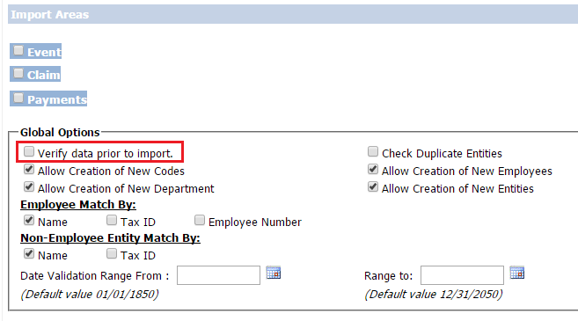

***Figure 36:*** *The DA DDSs Option set window*

DA DDS job will read the import files, Load them into the Staging database, validate the data and import the valid records.

If the User has selected *‘Verify data prior to import’* on DDS Optionset page and there is validation error in the import file then Job state ***Pending User Verification*** would be shown on TM Jobs View

If the User has *not* selected *‘Verify data prior to import’* on DDS Optionset page ***or*** the User has selected *‘Stop Verification’* on User verification screen and there is any validation error in the import file then Job state ***Completed with Validation Errors*** would be shown on TM Jobs View.

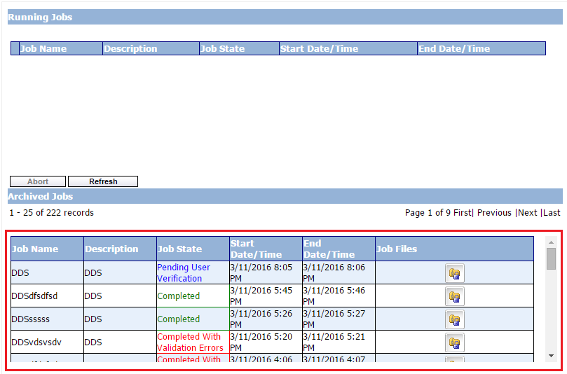

**Figure 37.** TM Jobs View

If any system error occurs while executing the job, then job state ***Completed with Errors*** *would be shown* on TM Jobs View  
When Job state is ***Pending User Verification***a user diary will be sent to the user who scheduled the DA DDS job. The user diary will contain a link to the User Verification screen. Diary can be opened by following the below mentioned steps

Diaries -> Diary List  
  
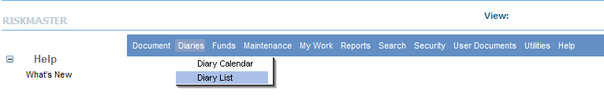

**Figure 38.** Dairy List

On the Diary List page, enter your Optionset name in Task Name text box to search Diary entry for your User Verification screen. After entering the Optionset Name select the filter symbol and select “*contains*”.  
The User Verification dairy for your Job will appear in the Diary List.  
Click on DDS in *Attached Record* to open your User Verification Screen.  
 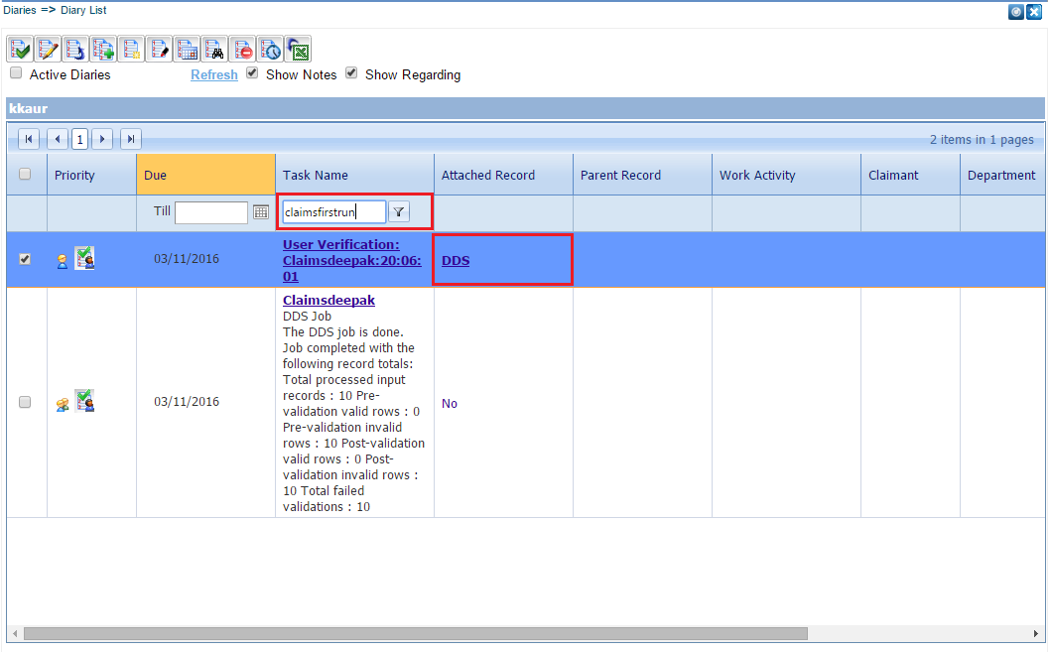

**Figure 39.** Diary List, Diary Actions

The User Verification screen will display all the invalid records by default in the grid format. User can view the validation errors in ***Row Error Summary*** by Selecting the Edit link for any failed record.

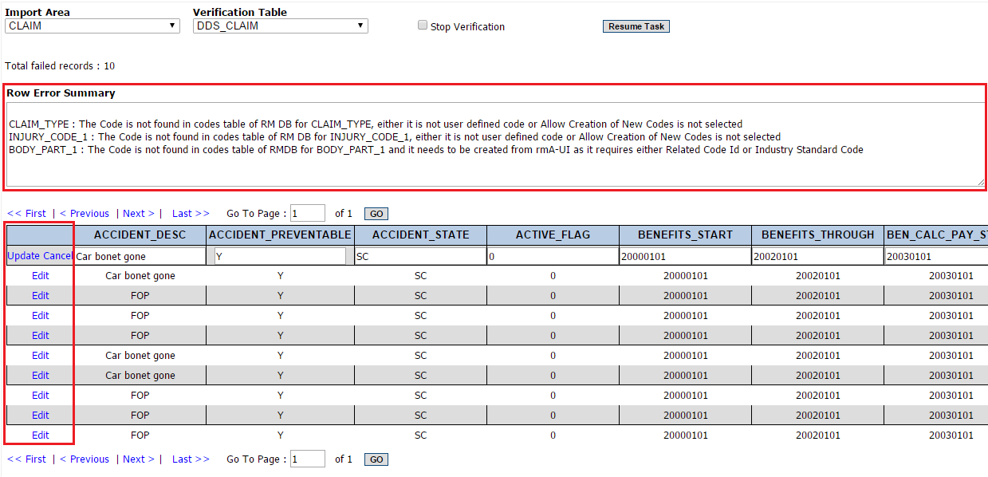

**Figure 40.** User Verification

All the fields corresponding to which any validation error has occurred would be highlighted in **Red** color. User can navigate to that column and make changes.

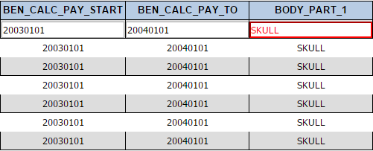

**Figure 41**. User Verification, Highlighted Error Record

After modifying the data for the failed record the User needs to select *Update* to modify record into the staging database. The same steps can be performed for all the failed records.



**Figure 42.** User Verification, Edit/Update

After modifications are complete, the user will click on the *Resume Task* button and the job will again be executed. The data is stored in the DA_RMX_STAGING database.

If there are records that are still not valid, a user diary will be created again and sent to the user. This process will continue until all records are valid or the “*Stop Verification”* checkbox is selected.

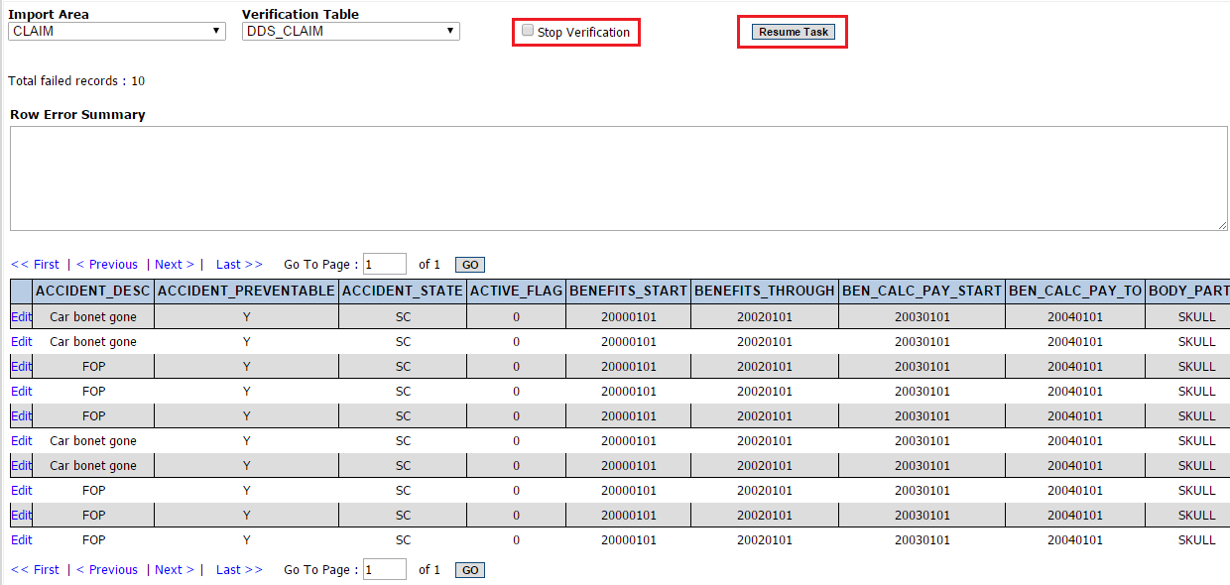

**Figure 43.** DDS User Verification, Resume task and Stop Verification

When the *Stop Verification* checkbox is selected and Resume Task is clicked, then DA DDS job will execute again. If there is any validation error then the job state will be ***Completed with Validation Errors*** and no further User verification diary will be created. If there is no validation error and all the records have been successfully imported into RiskMaster then the Job state will be ***completed.***

The user needs to re-schedule a new DDS job to process the remaining invalid records.

# DA DDS – Implementation Approach

## Introduction

A new and innovative approach has been implemented in DA DDS by including stored procedures. The ATL hence is very compact and efficient.

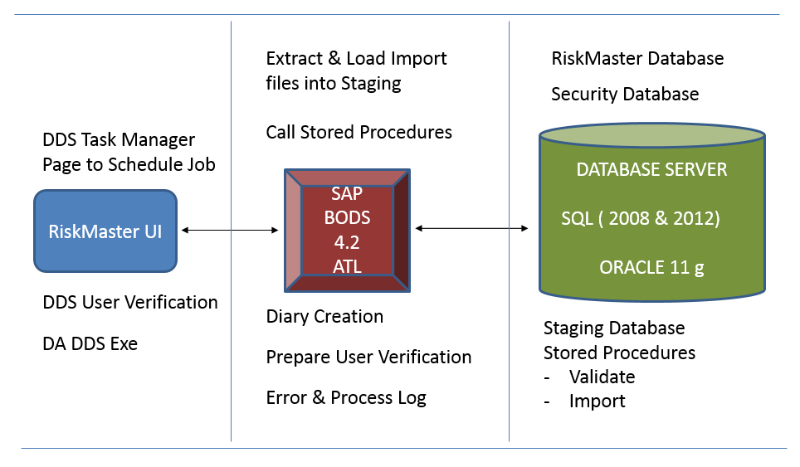

**Figure 44.** DA DDS Architecture

**RiskMaster Application Server:** RiskMaster UI (DDS Optionset and User Verification Screen), DA Configuration Files, DA_DDS.exe, DDSScriptTool.exe

**DB SERVER:** RiskMaster Database, Staging Database, Security Database, Task Manager Database, DA Repository, SAP BODS CMS & Audit Databases

**DA SERVER:** SAP BODS/ DA Job Server, Web Service to connect DA with RiskMaster.

# Points to Remember

* User must have created tables, procedures, functions, insert, delete, drop, execute procedures etc. Privileges on the staging database that is mentioned in the node **“*stagingdatasource*”** of the **“*connectionstring.config*”**. Make sure they also have select, update, insert and delete rights on RiskMaster Database from Staging Database.
* **RiskMaster database and staging database must be on a Single Database server Instance**

In case of SQL server below is the sample screen shot.  
  
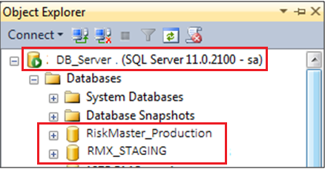

**Figure 45.** SQL Databases

* In case of Oracle, Staging and RiskMaster Database both must be on same database. They can have different user/ schema name on it. Example:
  + DB Name : ORCL
  + IP Address: X.X.X.X
  + Staging Schema Name: STAGINGDB
  + RM Schema Name: RMDB
* In case, user wants to abort the running job through TM Jobs View page then there may be a chance that a deadlock gets created in database.

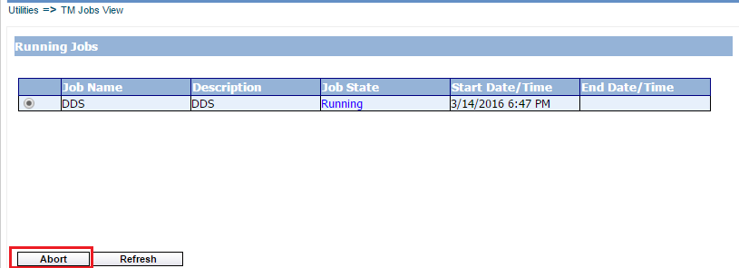

**Figure 46.** Tm Jobs View, Abort Job

# Functionalities Improved In DA

COMMON:

1. **Allow Creation of New Codes**
   1. ***Desktop DDS*** used to create all codes irrespective of other mandatory codes required to create that code, which was not in sync with RiskMaster Functionality.
   2. User defined codes that ***do not*** require *Parent codes* and *Industry Standard codes* can be created through ***DA DDS***.
   3. User defined codes that require *Parent codes* and *Industry Standard codes* should be created using RiskMaster Table maintenance Functionality.
2. **Tax ID Fields Validations**
   1. TAX_ID fields should contain 9 numeric characters excluding hyphens (**-**), violation of which would result in an error.
3. **Flag Fields Validation**
   1. In the import file all the flag columns can accept only two values either 'Y' or 'N'.
   2. The ‘Y’ will be imported as “-1” and 'N' will be imported as “0” in the RiskMaster.
4. **Phone Fields Validation**
   1. Phone Number fields should contain 9 numeric characters excluding hyphens (**-**), violation of which would result in an error.
5. **ZIP Code Fields Validation**
   1. Zip Code fields should contain either 5 or 9 numeric characters excluding hyphens (**-**), violation of which would result in an error.
6. **Non-Employee Match By**
   1. Options under this heading in ***Desktop DDS*** were radio buttons in which user was able to select only one but in ***DA DDS*** these have been converted into Checkboxes so that user can select multiple options based on their requirements.
7. **Employee & Non-Employee Match by**
   1. If TAX_ID is selected and TAX_ID is not provided in import file then in ***DA DDS*** it would give an error.
   2. **Desktop DDS** used to fetch entities in an improper way which used to corrupt data and doesn’t used to log an error.
8. **Use TAX ID in Entity Matches (Still Uses Name)**
   1. This Option specifically has been removed. User would have to select NAME and TAX_ID both checkboxes to perform this functionality.

EVENT IMPORT AREA

1. **Disability Code Validation**
   1. Disability Code validation can accept only two short codes either "ILL" or "INJ"
   2. If given value "ILL" as short code then there must be a value given in Illness_Code column otherwise an error will be logged.
   3. If given value "INJ" as short code then there must be a value given in Injury_Code column otherwise an error will be logged.
2. **Create New Department**
   1. ***Desktop DDS*** does not used to Create New Department for Events Import area even if the *Create New Department* checkbox was checked. This functionality was not correct.
   2. ***DA DDS*** *Creates new Department* for Events Import area provided *Create New Department* checkbox is checked.
3. **Create New Employee**
   1. If this Checkbox present on the UI is unchecked and value given in Employee related columns in import file and it does not exists as an Employee in RiskMaster database then an error will be logged in this case.
   2. If this Checkbox present on the UI is checked and value given in Employee related columns in import file and it does not exists as an Employee in RiskMaster then new employee will be created in this case.

CLAIM IMPORT AREA

1. **Reserves**
   1. PAID_TOTAL & COLLECTION_TOTAL fields in import file are **no more used** to insert/update PAID_TOTAL & COLLECTION_TOTAL in RESERVE_HISTORY and RESERVE CURRENT Table
2. **Add Claimant as Person Involved**
   1. If this checkbox is checked on RiskMaster UI in *General System Parameters* settings then, CLAIMANT would be added as a person Involved at Claim Level which was not present in ***Desktop DDS***.
3. **DATE_WORKED_LAST & DATE_RETURNED**
   1. These fields will not be used in **DA DDS** as these were duplicate fields. Existing fields ***DATE_LAST_WORKED* & *RETURN_WORK_DATE*** would be used now for the same purpose.

PAYMENT IMPORT AREA

1. **Unit Level Reserve Tracking**
   1. Earlier in Desktop DDS, Reserves were not tracked on UNIT Level for Vehicle Claims when Detail level Tracking was turned on. DA DDS provides this functionality to create Reserves and make Transactions for Vehicle Claims on Unit Level.
2. **Ability to provide Claimant Information different than Payee**
   1. Desktop DDS does not provide functionality to provide Claimant Information other than Payee information. Instead, Payee information was used to identify Claimants if Match by Name option was selected for Claimants. DA DDS contains different Columns for Claimant to identify on the basis of Name or Tax-Id
3. **Employee Type Payee can be identified on the basis of Employee Number**
4. DA DDS provides the functionality to identify Payee on the basis of Employee Number using new column added in Payments.csv i.e. EMP_NUM.

SHORT TERM DISABILITY IMPORT AREA

In Desktop DDS both Short Term Disability Plan and Class files were required if Short Term Disability checkbox was checked. If one of the file used to be missing an error used to be logged.  
DA DDS provides the flexibility to the user to select either one of them or both of them, but if none of the files are selected then a validation error will be logged.